1. MongoDB document stores document in BSON format.
2. **BSON document** consists of key-value pairs.
3. Each value must have a type assigned to it.
4. So BSON stores value and its type.
5. Before storing information into the MongoDB, you must instruct MongoDB which type you want value to have.
6. This instruction is given using type syntax.
7. Some types such as Strings, Objects, Arrays and Boolean don’t require any additional information you need to add to the value.
8. If you use double quotes, mongoDB will understand that you want to store string and the type would be string.  
   If you use curly brace {}, MongoDB will understand that this is an Object and type will be an Object. Same is with Array and Boolean.
9. But if you want to store Number, ObjectId, Date, you must supply types information along with the value.
10. 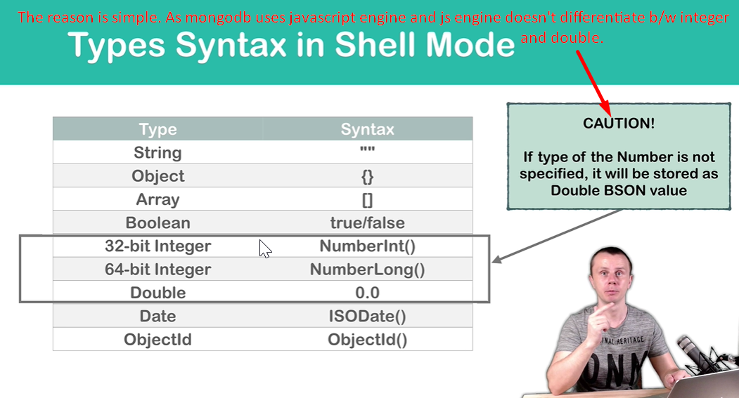
11. 